**Northwind Data Analysis**

use [Northwind]

1) Find top 20% product genrating maximum profit.

select top 20 percent ProductName,categoryname,

SUM(od.UnitPrice*Quantity) as total_salse

from Products

inner join Categories

on Products.CategoryID=Categories.CategoryID

inner join [Order Details] as od

on Products.ProductID=od.ProductID

group by productname,categoryname

order by total_salse desc

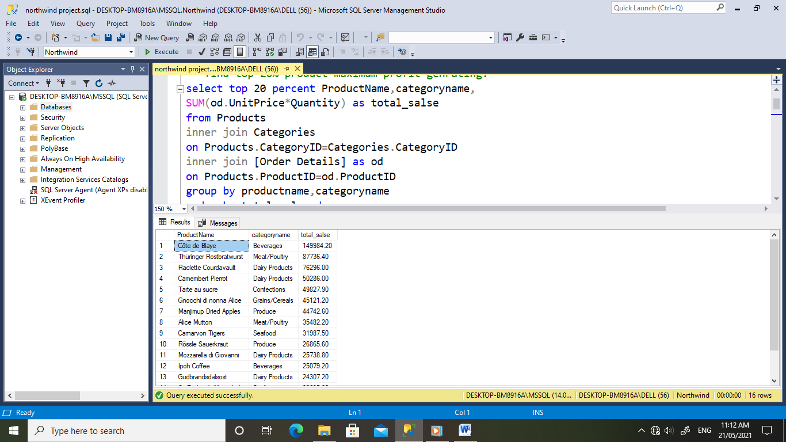

2) Finding top 20% customer and how much revenue getting from that.

select top 20 percent od.unitprice*quantity as total_salse,ContactName

from Orders

inner join [dbo].[Order Details] as od

on Orders.orderID=od.OrderID

inner join customers as c

on c.CustomerID=orders.CustomerID

order by total_salse desc

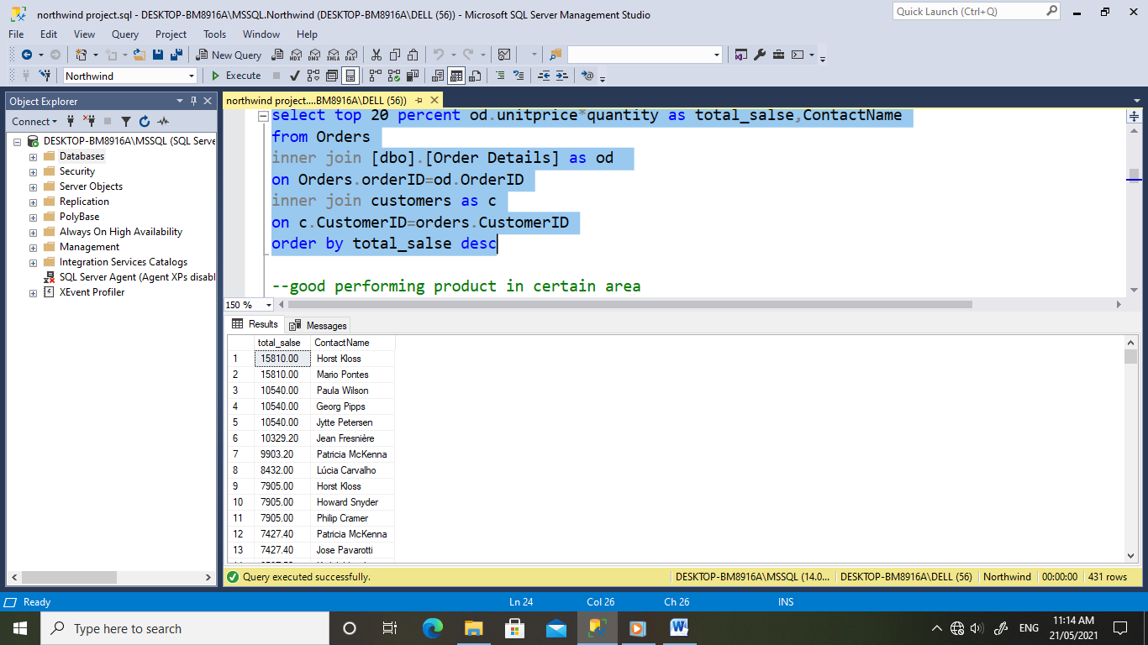

3) Good performing product in certain area

select top 50 od.Quantity*od.UnitPrice as total_salse,p.ProductName,Region

from [Order Details] as od

inner join Products as p

on od.ProductID=p.ProductID

inner join Suppliers as s

on p.SupplierID= s.SupplierID

where region is not null

order by total_salse desc

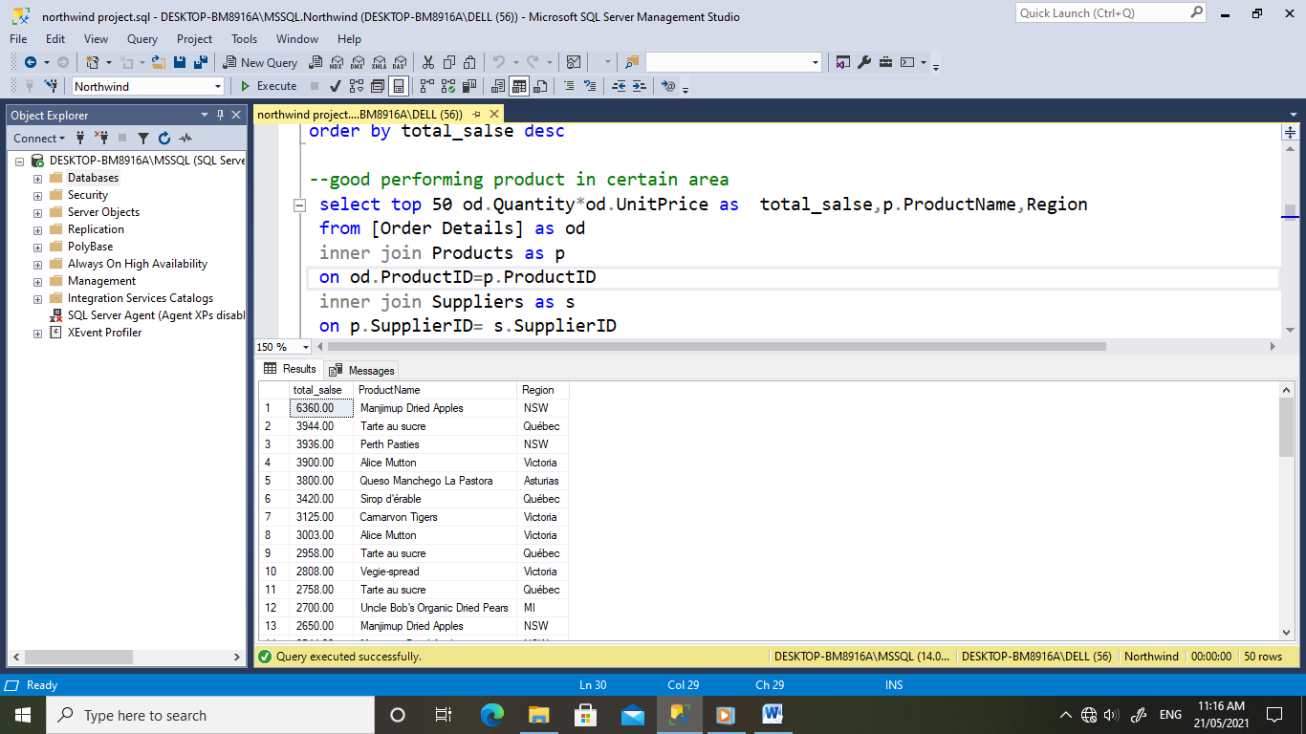

4) Low performing prodcut and region

select distinct top 50 od.Quantity*od.UnitPrice as total_salse,p.ProductName,Region

from [Order Details] as od

inner join Products as p

on od.ProductID=p.ProductID

inner join Suppliers as s

on p.SupplierID= s.SupplierID

where region is not null

order by total_salse

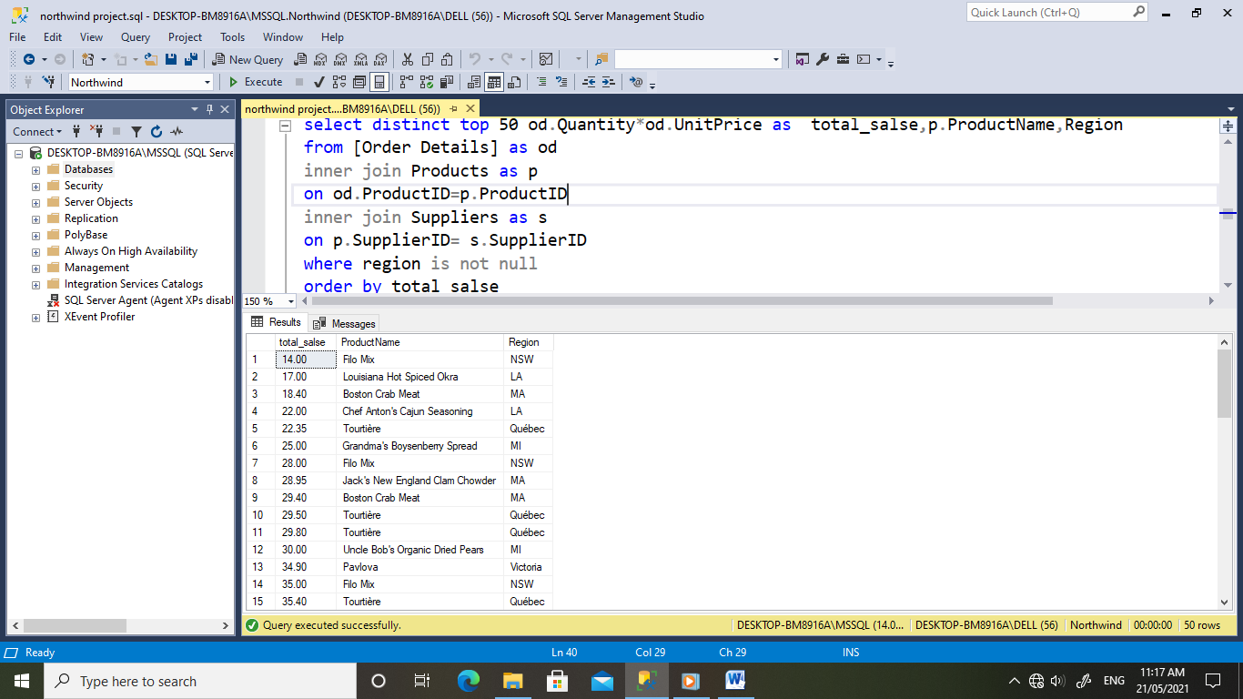

5) Best performing employee on the besis of order

select count (O.EmployeeID) as SaleByEmployee,O.EmployeeID,E.FirstName,E.LastName

from Orders as O

inner join Employees as E

on o.EmployeeID=E.EmployeeID

group by O.EmployeeID,E.FirstName,E.LastName

order by SaleByEmployee desc

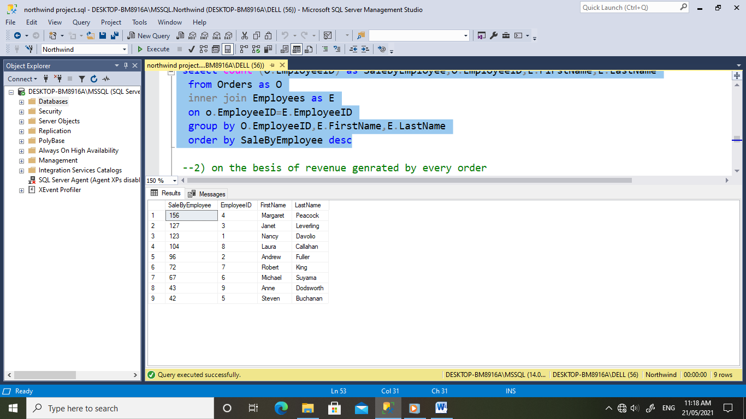

6) on the besis of revenue genrated by every order

select sum(Quantity*UnitPrice) as TotalSales,E.FirstName,E.LastName,E.EmployeeID

from [Order Details] as od

inner join Orders as o

on od.OrderID= o.OrderID

inner join [dbo].[Employees] as E

on o.EmployeeID=E.EmployeeID

group by E.EmployeeID,E.FirstName,E.LastName

order by TotalSales desc

